How to Guide:
Appealing late filing penalties

Background
This guide covers cases where the client has received late filing penalties for not filing their Tax Return by the due date. Up to 2009/10 the Tax Return filing deadline was 31 January with a late filing penalty of £100 and a further £100 six months later – on 31 July. From 2010/11 the deadline changed to 31 October for a paper filing or 31 January for an online filing. The penalty regime is as follows (bold indicates the online deadlines):

1 day late (1 November/1 February) | A penalty of £100. This applies even if you have no tax to pay or have paid the tax you owe.
3 months late (1 February/1 May) | £10 for each following day - up to a 90 day maximum of £900. This is as well as the fixed penalty above.
6 months late (1 May/1 August) | £300 or 5% of the tax due, whichever is the higher. This is as well as the penalties above.
12 months late (1 November/1 February) | £300 or 5% of the tax due, whichever is the higher.  In serious cases you may be asked to pay up to 100% of the tax due instead.  These are as well as the penalties above.

e.g. A 2019 Tax Return is due on 31 January 2020 for online filing. Penalties will arise on 1 February 2020, 1 May 2020, 1 August 2020 and 1 February 2021 if it is filed online later.
TaxAid can request reviews of penalties on the client’s behalf explaining what prevented the client filing. We may also mention the client’s current financial circumstances. Examples of such claims and the income and expenditure form can be found in Appendix 1 and 2.

How TaxAid deal with late filing penalties
Step One - Contacting HMRC
- Make sure you have a signed Fast Track form in place or that audio consent has been received – this should show clearly on the form. Call HMRC Fast Track to confirm why Tax Returns were issued to the client. If the cause of the Tax Return is solely a PAYE underpayment we generally do not complete Tax Returns/appeal penalties – we try to get withdrawal of Returns – see ‘How to Guide – P800s’. If the cause was a self-employment or other untaxed income we need to obtain further information.
- Confirm the start date of the source of income according to HMRC’s records and also whether they have been informed of any end date (if appropriate).
- Confirm which tax years have late filing penalties. For each year either find out if the Tax Return is still outstanding, or, if filed, the date it was received by HMRC.
- Ask HMRC to check for notes of any telephone calls or letters sent in by the client in relation to trying to complete Tax Returns/appeal penalties. This should cover the period since the filing deadline for the earliest Tax Return. HMRC will sometimes refer to contact made by a client as a reason to dismiss an appeal – so it is useful to get feedback from the client on why any contact with HMRC did not resolve their problem.
- Request a detailed Self-Assessment statement of account and put debt collection on hold for a month (if possible).
All these details may not be needed in all cases. Your conversation with the experienced Fast Track team should enable you to obtain all the facts relevant to your case.
Step Two –Completing outstanding Returns where required
A late filing penalty appeal cannot be considered by HMRC until it has processed all outstanding Tax Returns. You will therefore need to complete any Tax Returns where the client meets the criteria for a Self-Assessment. If it comes to light that Tax Returns have been issued for periods when the client had no self-assessment criteria you can call Fast Track to request withdrawal.
See ‘How to Guide – Completing Tax Returns’.
Step Three – Contacting the client and making the appeal
Appeals against penalties can be made
- on the grounds of reasonable excuse for not filing in the relevant period and
- on the basis that the client does not meet the criteria for a Self-Assessment – also referred to as requesting ‘withdrawal’ of a Tax Return and penalties
Although it is not part of an appeal we will also put in a paragraph regarding the clients’ financial means. Historically, HMRC conducted ‘reviews’ of late filing penalties which included effective cancellation of penalties on the grounds of financial hardship – however this changed in mid 2019. TaxAid still includes this paragraph on financial means for two reasons. Firstly HMRC’s policy may change again to allow consideration of hardship. Secondly, if the appeal fails on reasonable excuse, HMRC can sometimes suggest we approach the collection wing of HMRC (via Fast Track) with a detailed income and expenditure account to consider indefinite non-pursuit of penalties (distinct from outright cancellation). For more information on non-pursuit of tax debt please see ‘How To Guide- Handling Tax Debt’.
We therefore need to carefully check the client case summary and speak with the client to confirm or gather information pursuant to reasonable excuse, withdrawal and hardship.
Reasonable excuse
The relevant period is from the filing deadline to shortly before you actually file the Tax Return. It is important that, when you speak with the client, you concentrate on this period as clients may talk about earlier incidents which are not relevant. If they do this you need to consider if this was an ongoing situation that would have lasted into the relevant period. e.g. An unresolved bereavement relating to a relative dying in 2013 caused the client to see his GP in January 2017 - should be considered relevant for a 2015/16 penalty review. Do not mention events that do not impact the relevant period. Getting dates or rough periods for the situations described below is vital as it allows HMRC to consider if the excuses are in the relevant period.
When speaking with the client explain that you want to make as robust an appeal as possible on their behalf– and remind them of the quantum of the penalties and the importance of mentioning all relevant details. Explain that this might mean that you have to ask some personal questions to give the client the best possible chance of reducing the penalty charge.
To enable HMRC to fully consider the appeal the following information should be provided:
1. The date of any physical illness/mental health issues/bereavement or event that occurred. Approximate dates are acceptable especially re mental health issues e.g. ‘mid way through 2018’. If there is no approximate date provided and the appeal hinges on it - then it will be refused. Avoid saying the client was treated for depression without stating a date/period. Also avoid any self-diagnosis – only diagnoses by a medical professional are admissible.
2. In the case of illness did the client receive medical treatment and what form did it take? (GP/Hospital/specialist/therapy or medication?) If the client did not go to the GP can we point to other things that happened in the client’s life that were a consequence of undiagnosed mental health issues e.g. alcohol/drug addiction or homelessness?
3. How long did the illness last and how did it affect their day to day life? Where the client has continued to trade during a relevant period you need to, diplomatically, enquire as to how they managed to trade but not fill in a Tax Return form. Often the answer will be that the skills required to trade will be different from the skills required to fill in a form.
4. Where a person is caring for a seriously ill relative how did this affect their lives? How much of their time was taken up? You need to build up a typical day/week to show that there was not enough time/physical and emotional resources to meet their SA obligations.
5. In the case of bereavement if the relationship to the deceased is not obvious (or obviously close) did the client live with or care for the deceased?
6. Provide information on the client’s capability that may have impacted on their ability to meet their obligations e.g. formally diagnosed dyslexia, language difficulties, unfamiliarity with the UK tax system, disability, education, job, age, nationality, if an agent is acting etc.
Financial Hardship
- Information re financial hardship. If the clients are on benefits we just need to state this fact. If they are in employment HMRC will want a current ‘basic’ Income & Expenditure (Details of net salary and expenses such as rent, council tax, utilities and food) as well as details of savings, current health problems. In the KANA we just need to state that the client has a negative or nil disposable income.
Withdrawal on the grounds of no Self-Assessment criteria
- If the client’s trade has ceased and they have a Tax Return for a tax year after the year of cessation you can request withdrawal of the Tax Returns on the grounds that the client does not meet the criteria for a Self-Assessment for that year. If the client has already submitted Tax Returns showing ‘zeros’ for self-employed income you can refer to this fact as confirmation that the trade actually ceased at an earlier date.
You should then compose the late filing penalty review. TaxAid has a standard appeal against late filing penalties. Go to SalesForce ‘Generate Letters’ and select ‘KANA LFP review for SE cases or where A19 has failed’.
If you hold any evidence regarding the client’s assertions then make a note of it in your appeal. Sadly we cannot scan this with the email appeal so simply state in the appeal that we have the evidence. e.g. “TaxAid holds evidence of X i.e. a letter dated Y from the client’s doctor”.
Please see Appendix 1 for examples of penalty review wording covering reasonable excuse and hardship. Appendix 2 is a standard income and expenditure form which a client can complete with estimates to support any claim TaxAid makes regarding their disposable income and that collection of penalties will cause financial hardship. Please refer to the Late filing penalty appeal checklist in Appendix 3.

Step Four - Reply from HMRC and how to decide on any further action
When HMRC reply they will either:
• Agree to reduce/cancel all/some late filing penalties on appeal
• Not agree to do so
1. Agreement to an Appeal - If HMRC agrees to your appeal this legally changes the debt to the true tax position – which might be nothing to pay or even a refund of payments already allocated against a penalty.
- Refusal of an Appeal - A refusal to an appeal can have serious financial repercussions for the client. In this instance we need to decide whether it is possible and worthwhile to make a further appeal or whether we need to advise the client regarding debt management.

Generally a second appeal is possible unless the client already had refusals before they came to see TaxAid. You can check with HMRC as to whether it is possible to do a second appeal – or if the only appeal option is to take it to independent Tribunal.

To check if the appeal is worthwhile you may want to

- Review the case and see if the response from HMRC was unexpected.
- Is the response atypical bearing in mind other cases you have seen.
- Obtain a copy of the refusal letter from HMRC and see if it makes points that can be rebutted or answered.
- Speak again with the client to see if there is further information re reasonable excuse. Sometimes a refusal makes them provide new information.
You may want to discuss the case with your TaxAid buddy to see if they can make any suggestions in this instance.
If you decide to do a second appeal then you should draft and submit this to HMRC via the KANA system headed up as a further appeal against late filing penalties.
Step Five - Communicate end result to the client
1st appeal is successful:
You will need to check that the client’s Self-Assessment statement of account or PAYE tax code has been updated to cancel penalties, check on any final liabilities/overpayments per Tax Returns submitted and advise the client. Please go to ‘How To Guide – Completing Tax Returns’ – Step 5.
1st appeal failure – decide not to appeal a second time
If you have decided not to do a second appeal then you can advise the client of their right to appeal to HMRC (normally required within 30 days of the first refusal), any tax liabilities per Tax Return and their debt management options. In some case it might be possible to ask that HMRC do not pursue the debt on an indefinite basis. Please go to ‘How To Guide – Completing Tax Returns’ – Step 5.
1st and then 2nd appeal failure
If there is a second refusal then this normally exhausts the HMRC appeals process and if clients want to take it further they would need to appeal to independent Tribunal. At the time of writing TaxAid does not have the resources to take cases to Tribunal.
You can advise the client of their right to appeal to Tribunal (normally required within 30 days of the second refusal), any tax liabilities per Tax Return and their debt management options. In some case it might be possible to ask that HMRC do not pursue the debt on an indefinite basis. Please go to ‘How To Guide – Completing Tax Returns’ – Step 5.

Appendix 1
Example 1
Please review the penalties for three years to 5 April 2016. The client has had mental health issues since May 2012 suffering from severe depression and often being suicidal; she has not been able to face her GP and has tried to manage alone. Her health problems affected her ability to complete Tax Returns because the depression prevented her attending to financial matters. Although the client was trading in the relevant periods it was at very low levels and her music gave some distraction from her depression. The client has experienced some difficult life events: in May 2012 the client’s partner of 6 years was arrested. The client was also arrested but released. She was traumatised for a year due to the investigations. In April 2014 the partner was imprisoned and the relationship broke down. She became subjected to abuse and threats on her and her family’s life. Her depression deepened, she was alone, afraid for her life and not able to live in her own home and was sofa surfing. The ex partner was released from prison in 2016 but he had become mentally unstable and began harassing the client. She had to hide and change home and phone numbers. In 2017 the client’s mother became almost blind, she had surgery and then had a stroke. The client was a member of a band which broke up in 2015 which resulted in a reduction in income and the client having to go it alone. Whilst a member of the band all tax matters had been handled by the band manager with an accountant, then the client had no one. The client is on a low income and will struggle to pay this debt; we have completed an income and expenditure form and she has no disposable income. She has loan and other debts of £20K. Please consider this case sympathetically.
Example 2
Please review the late filing penalties for the year ended 5 April 2017. Our client was not born in the UK and has been working as a mini cab driver. He has a very limited understanding of the UK tax system. The client seeks to be tax compliant but he has no means to pay an accountant. He is 73 years old and, in his own words, 'he is not very clever'. He does now own a computer but is unable to prepare tax returns without assistance. We have assisted him in preparing his outstanding returns for the two years ended 5 April 2018 to get his affairs up to date and these were submitted online on Friday 22 June 2018. He ceased his self-employment on 5 April 2018 and subsists on a small state pension. Please consider this case sympathetically.
Example 3
Please review the late filing penalties for 2011 to 2017. The client has had various troubling life events since a very difficult divorce from his first wife in late 2011, they had three children and custody is shared. The client met a new partner in 2012, he married her in July 2013. This wife suffered from severe mental health issues, she was also registered disabled. The client’s wife already had three children and with her health conditions the client was spending most of his life caring for his wife and running around for all the children. His wife was being treated by seven different hospitals and he had to take her. The client had no spare time in his life to focus on things such as his tax. The client and his new wife had their first child in July 2014, the child stopped breathing on two occasions and almost died, for some three years the client was unable to sleep and watched the child through the night. The client discovered his wife has had two affairs and this resulted in the marriage failing and a very messy divorce. The client is stopped from seeing the children. Over the years since 2011 the client has become more and more stressed and finally he visited his GP in October 2017, he has been diagnosed as having long-term stress since 2011, he is receiving counselling and has been prescribed with sleeping tablets. Although the client was trading in the relevant periods it was at a very low level and he has not worked since December 2017. The client is a builder which uses different skills from those required to complete forms. The client has no income or savings and is applying for benefits; the client has debts for Council Tax and utilities of some £4K. Please consider this case sympathetically.

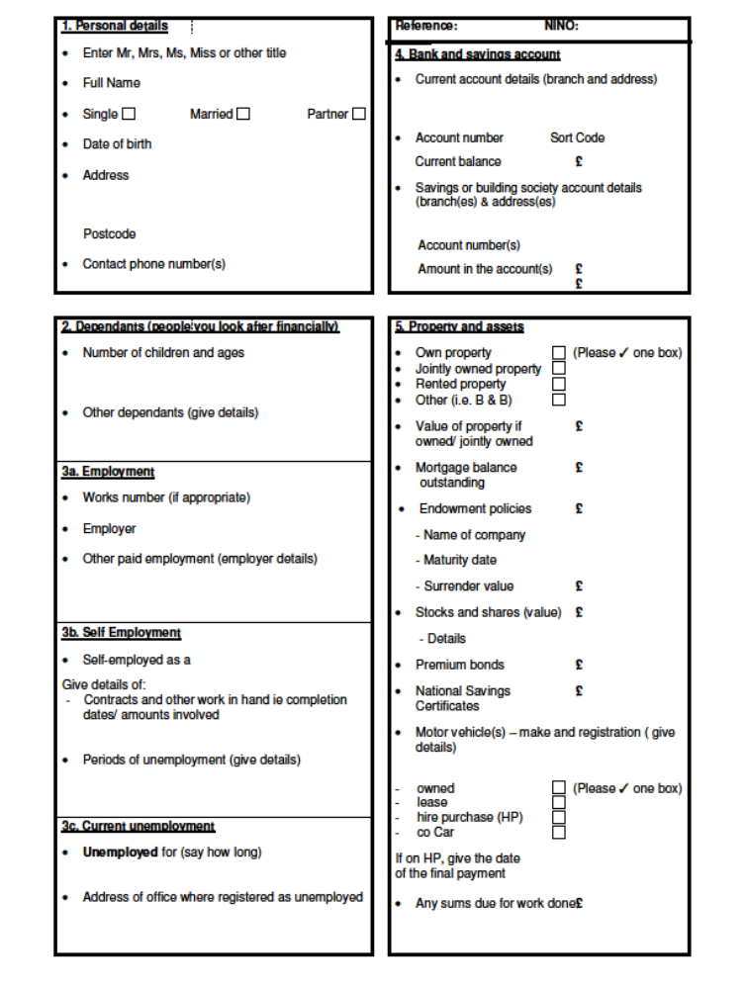
Appendix 2

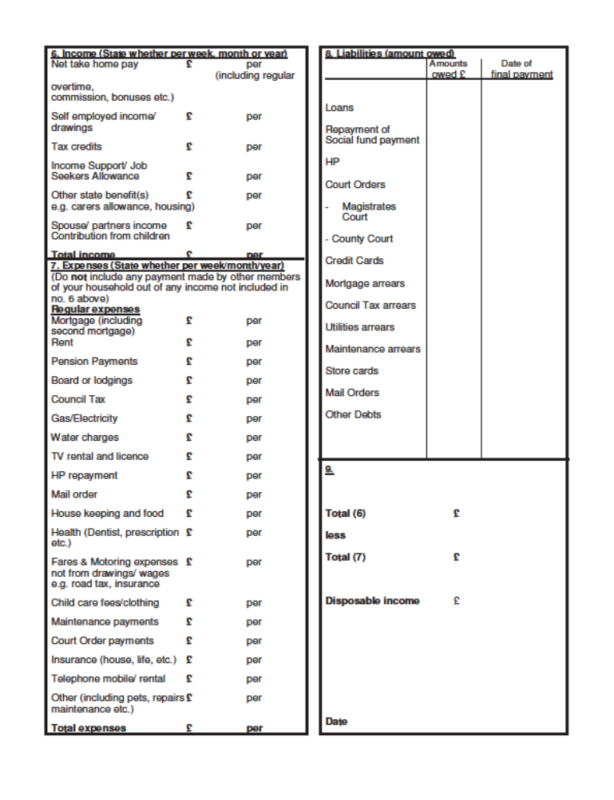
Appendix 3

Late filing penalty appeal checklist
Questions for client
Client:…………………………………….
Salesforce reference:………………………
Tax Year where there are penalties:………………………………………..
Relevant period*: ……………………………………….
Sensitively enquire whether any of the following apply to the client for the relevant period (please tick the box on the right once you have asked the questions).
Physical or mental health issues – if so when did they seek help and what medication/therapy.
Difficult life events: bereavements, homelessness, frequent house moves, accidents, breakdowns in relationships.
Caring responsibilities: Care for a friend/relative – we need to know tasks undertaken, time spent during a typical week.
Capability issues: Dyslexia (diagnosed), dyscalculia, dyspraxia, poor grades in Maths/English, leaving school early/truancy.
Alcohol or drug dependency issues – if so when.
If not born in the UK when did they enter the UK. What is their first language?
What is their current income level? Savings? Assets?

*The relevant period is normally from 31 January following the earliest tax year to the date the Tax Return(s) were actually submitted.

