Tax Charities Salesforce Implementation

Helpline User Guide

CONTENT

Contacts - create and edit

Cases - create and update

Initial call – how to record on the system (Create a task)

Initial call follow up options - how to record on the system

No follow up required

Sending information to a client (Email or Letter)

Sending out a fast track form

Obtaining GDPR 3rd party consent

Scheduling Client appointment ( F2F or Telephone etc.) via a calendar & how to add Calendars

Making a reservation/placeholder in a calendar ( where you need to book the appointment when on a live call before you have time to create the contact and case)

Asking the office manager to take an Audio consent

Making a note of a call from the existing client who already have a TaxAid adviser allocated

Editing the Case summary as you get more information from the client

Login and create & edit a contact

  - Login - Login by using your login details.

In order to write up a record of the call a Contact has to be created first. Only after the Contact is created, will the system allow you to create a case and an activity /task (e.g. Initial call).

  - Creating a Contact

Go to the Home tab and from here, go to the Contacts tab.

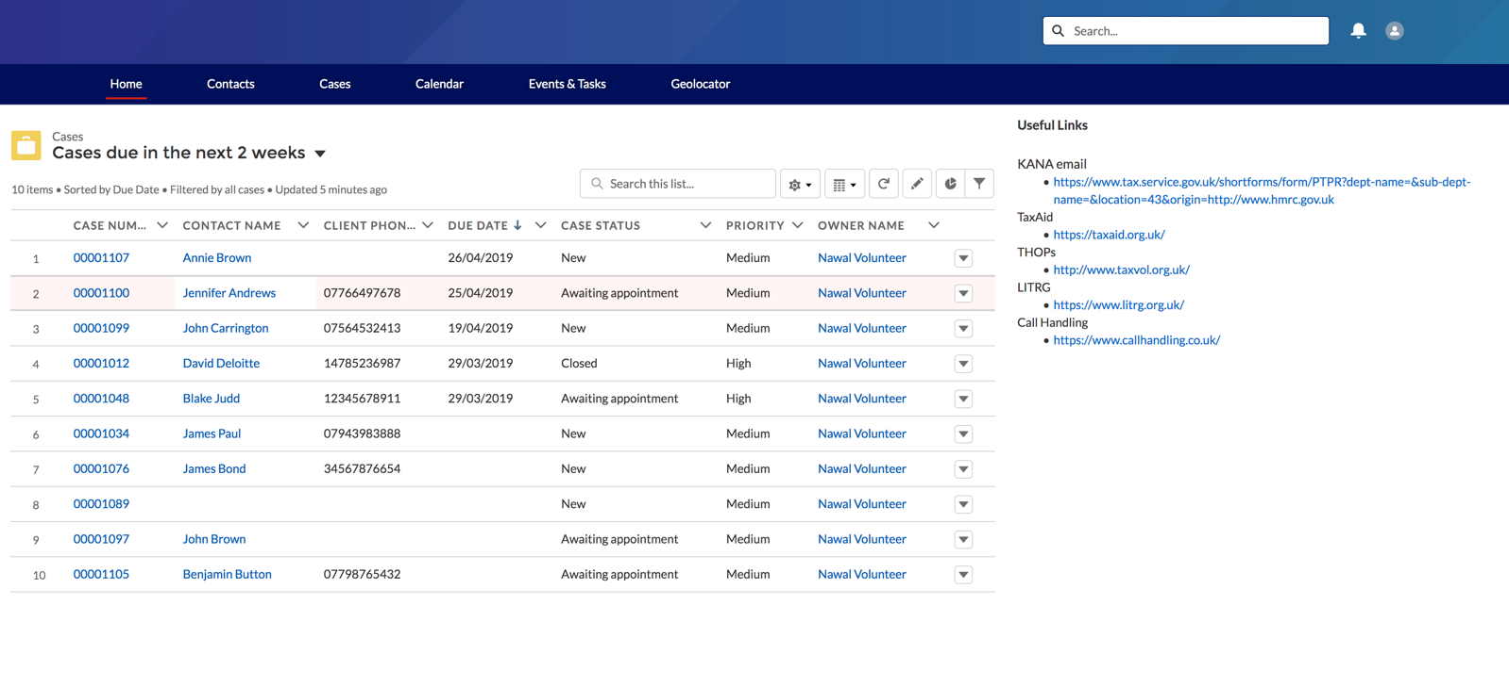

Click on the New button on the right side of the screen.

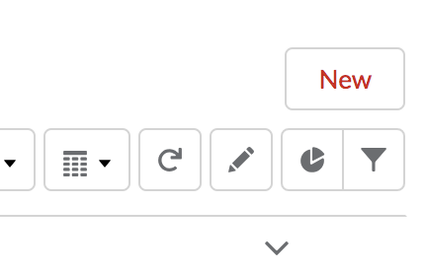
- Complete the form with the necessary information, making sure to fill in the required fields. Then click Save.

- This is where you note that GDPR consent has been received. This is a compulsory field. When you choose the ‘received’ option from the pick list the date of consent being received will be added automatically when you click save
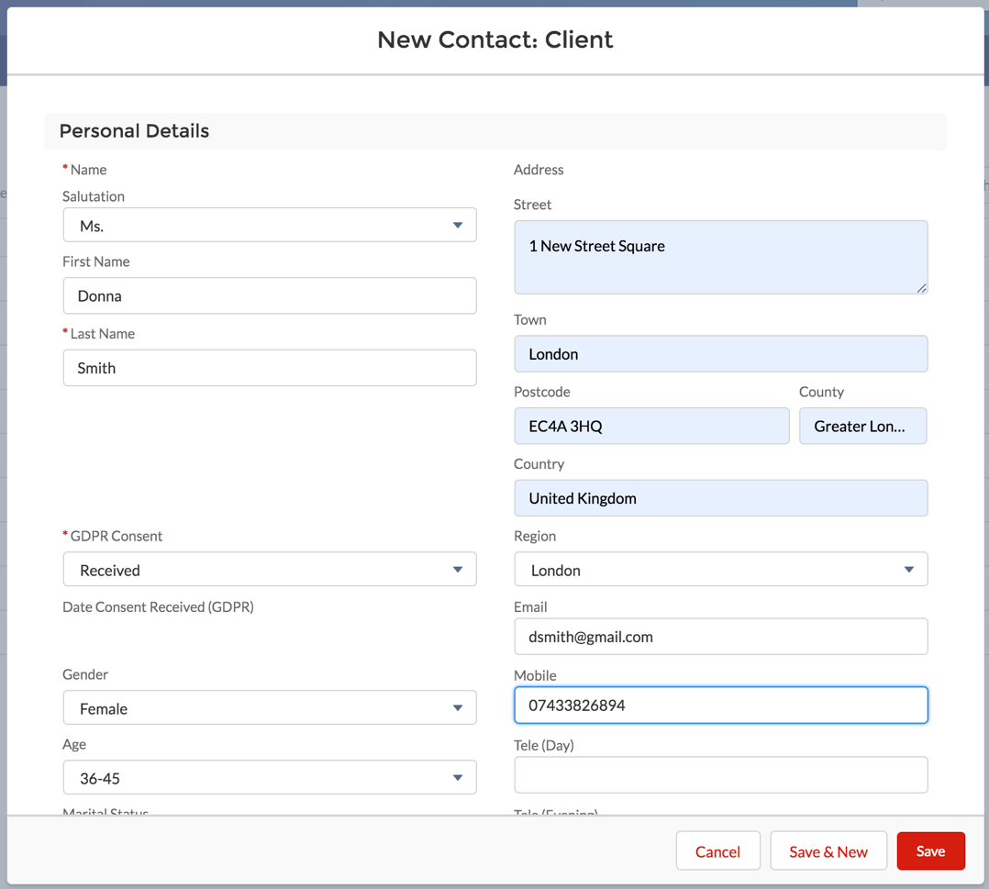

- If the message below appears when you click Save, click on View Duplicates to verify if the Contact you are entering already exists, if it does you need to go to the case ( see oooooooooooooo) ie this client already exists so you will need to add to the record, not create a new contact for an existing client.

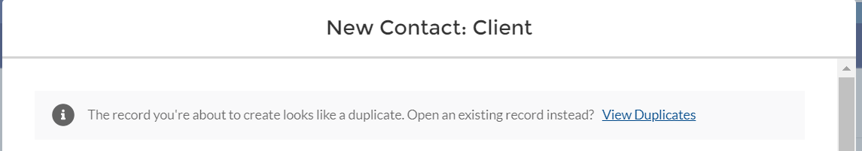

Edit contact

Once the contact is saved, you will be directed to its ‘contact record page’ (screen shot below). It defaults to the Details tab where you can see all the information you recorded on the previous page. There is an option to Edit the contact details.
- Once in Edit mode, you can update any details to correct them.
- Click Save
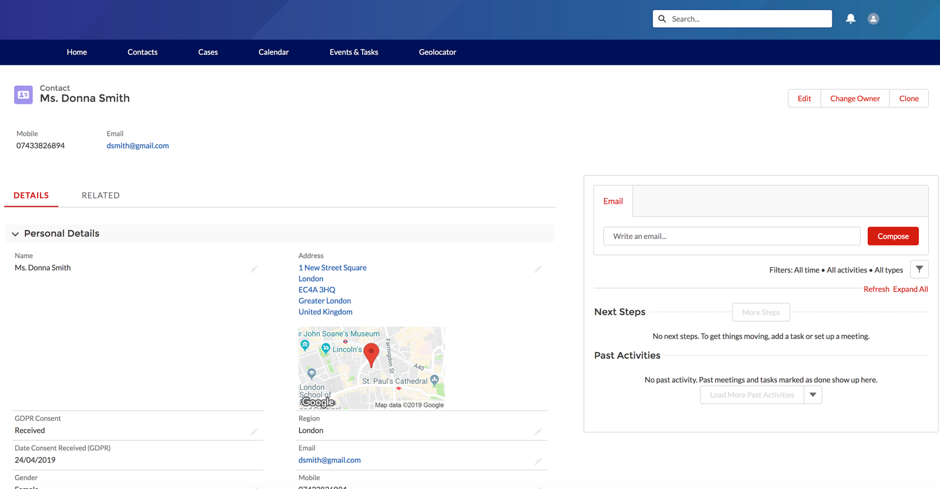

Cases - create and update

Having set up the Contact you now need to record further information about the client and the tax problem. In order to do so you will need to:

Create a Case

Populate the Case summary with the facts relating to the client and their problem

2.1 Create a Case

From the ‘contact record page’ Click on Related

In the Related tab, you can see the Cases and Activities related to this Contact. At present there are no cases or activities, as you only just created a Contact.

To create a Case (you need to create a case to note the details of the helpline call) - click on New

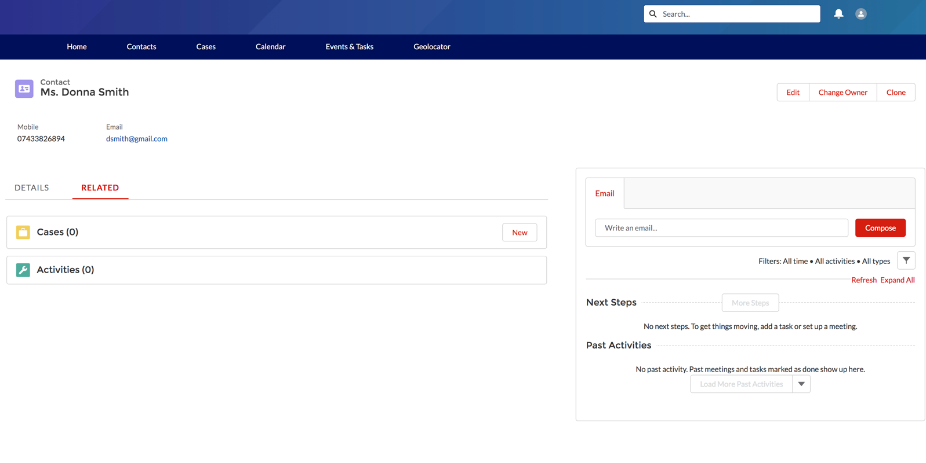

Populate the Case summary with the facts relating to the client and their problem

- As instructed above, click on ‘new’.
- “New Case” will open. This is where all the facts about the case should be captured.
The ‘Case summary’ should be kept up to date throughout the various interactions with the client to reflect the information you know about the case and the status of the case. This can be thought of as a ‘permanent summary’ at the front of a paper file that lets you know all the key facts of the case. Reading this should mean you know what the tax issue is and what the circumstances of the client are. The ‘tasks’ ( to be completed later) are just the activities you need to do in order to ascertain all the facts and steps you take to work to a resolution. ( More detailed Information on the ‘Case Summary’ in Appendix 1)

Complete the boxes with the facts of the case making sure to fill in the required fields, the required fields are asterisked.
- Click Save.
Note: NINO, UTR and Client Phone Number will be automatically populated with the information entered in the ‘contact’s record’ ( not case summary) once the new case is saved. You can go back and ‘edit’ the contact if you did not have these details when you created the contact.

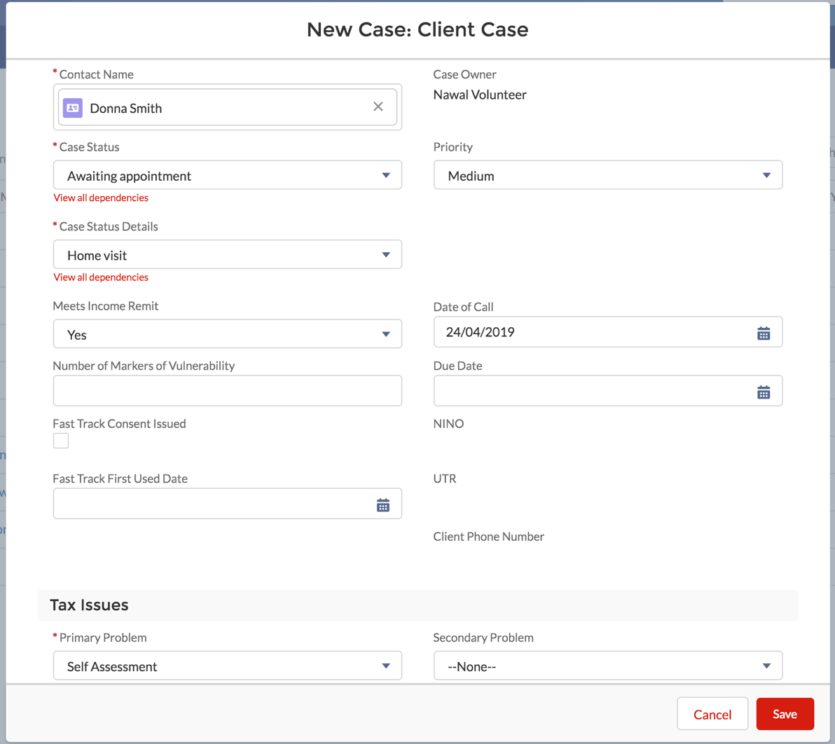

.

Once the case is saved, you will be directed to the Case record page (screen shot below).

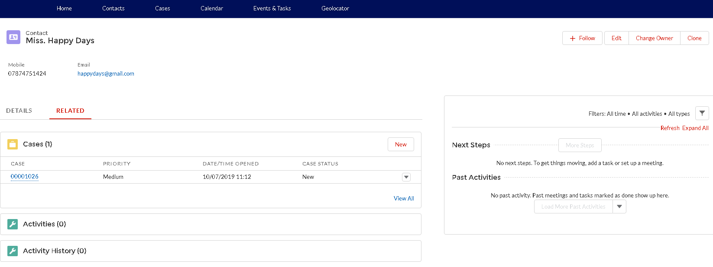

Please note:

Case record page - this is a place where you can:

Read, review and update the Case Summary;

Allocate tasks to casework volunteers or the Office Manager (e.g. to take Audio consent);

View completed tasks;

Upload documents;

On the right side of the screen you will see all the related activities to this Case: Open Activities (Events eg appointments not yet completed and Tasks), Activity History (completed - Events and Tasks), Files and Case Comments. NB Events refer to Client Appointments.

Note that NINO, UTR and Client Phone Number have been automatically populated with the information entered in the contact’s record.

Initial call – how to record on the system (Create a task)

Tasks are used to capture notes from various activities including phone calls and allocate tasks between various people working on the case.

Remember, when deciding what narrative should go into ‘task; or ‘case’ that the ‘case’ details provide details of the facts of the case and there is space to include additional freeform notes on the case in the ‘case’ summary under each category ( Tax issue, personal Circumstances and Financial Circumstances) , therefore the ‘task/activity ‘ note is expected to be brief ,eg ‘ the client called the helpline and explained the tax issue – details of facts in the case summary’ ie the ‘task’ is the action or activity and the case summary records facts.

3.1 To Create a task (e.g. to note the initial helpline call):

If you are not on the screen below, click on the ‘case number’

Then from this view, at the Open Activities section click on New Task.
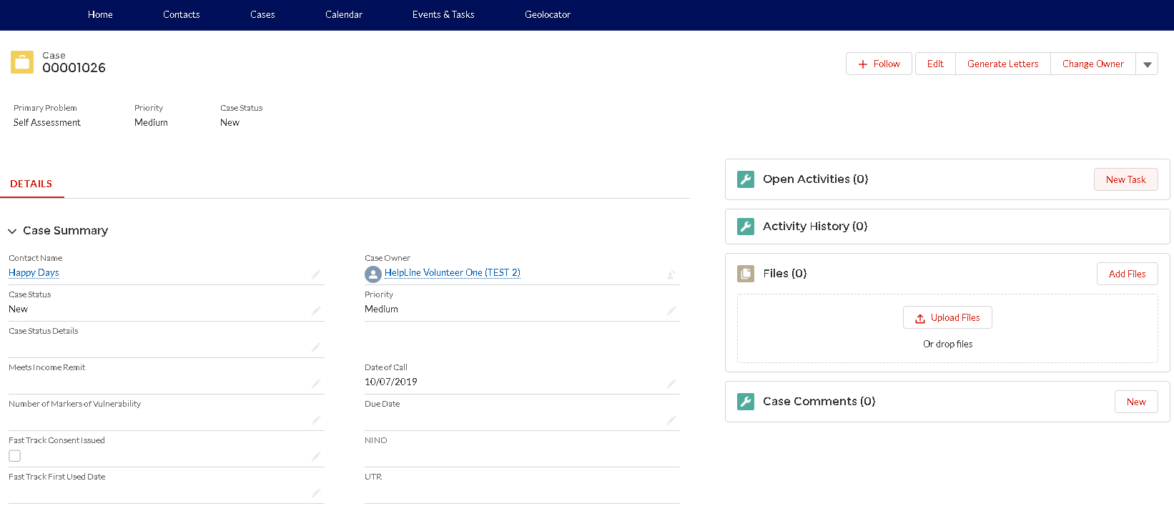

Enter the details of the Initial call on the helpline:
- Assigned To: as a default it will be assigned to you - No need to change;

- Select the Nature of Activity from the list of options. For initial helpline call the nature of the activity is ‘Initial Call’.

- Enter the Activity Date to indicate when the task has taken place if the task is completed (e.g. to record Helpline call put the date when the call has happened) or
when the task should take place if the task still needs to be completed;

- Priority - There should be no need to change the priority, it defaults to normal;

- Update the Status i.e. status of the ‘task’, not a status of the ‘case’ – this is an important distinction from the list of options. For a helpline call the status of this ‘task’ is ‘complete’.

- In the Comments box please note this was an initial helpline call. It is expected that the details of the case will be captured on the ‘case summary page’ you completed in 2. so these comments are expected to be limited, eg ‘took call on helpline - details captured on the case summary’ . It is expected that most details will be collected on the ‘case summary’ i.e. each section (Tax issue, Personal circumstance, Financial circumstances’) has a comments box and provides a permanent easily accessible record for the case details.

- Depending on the outcome of the call you may want to add that – ‘no follow up required’ ie if follow up is required an ‘activity’ or ‘task’ will be created – see later in guide)

Click on Save. VB – do hepline vold show this as completed or not?

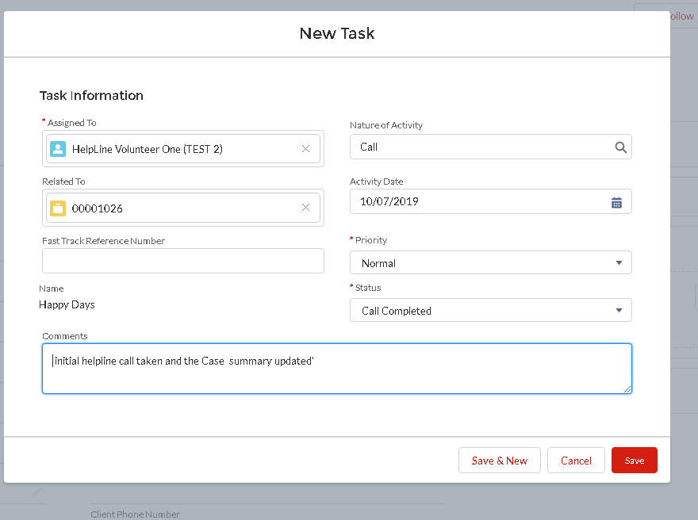

Initial call - follow up options - how to record on the system

Depending on the outcome of the initial call you will have different options:

No follow up required

You would need to do 2 things:
  - Update the ‘comments’ of the ‘task’ – ‘Initial call’
  - Update the ‘Case ‘– with both ‘Case Status’ and ‘Case Owner’ (where necessary)

  - Update the task comments ie task is-“Initial Call” to state that problem was resolved on the call, by:
Click on the greyed out pen next to ‘ comments’ and add relevant comments
Status of task ( initial call) – keep as ‘complete’.

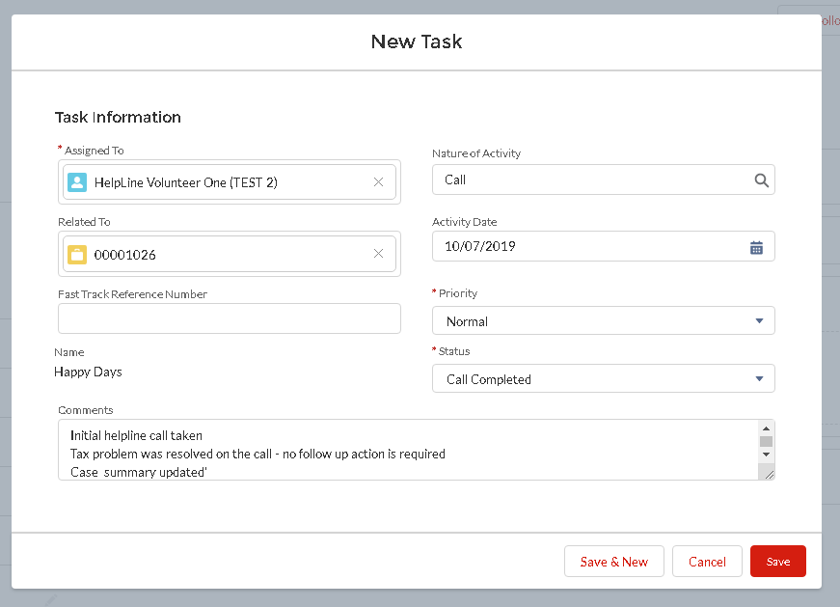

  - Update the Case ‘– with both ‘Case Status’ and ‘Case Owner’ (where necessary)

Click on the case number (e.g. 00001026) to get to the ‘Case record page’. Review that ‘Case summary’ is complete with information gathered in call and amend 2 fields IN THIS ORDER: ( ie it is important that you complete ‘case status’ before ‘case owner’ ie to protect client data not all case owners can access all cases, so if you update ‘case owner’ first you may lose access to the cases you expect to see.

3.2a Case status NB – THIS IS CASE STATUS NOT TASK STATUS– change the Case Status by clicking on a grey pen or by clicking on Edit

- FOR HELPLINE VOLUNTEERS – from “New” to “Returned by volunteer”
- FOR LONDON STAFF ON HELPLINE – from “New” to “Closed”
- And then click Save.

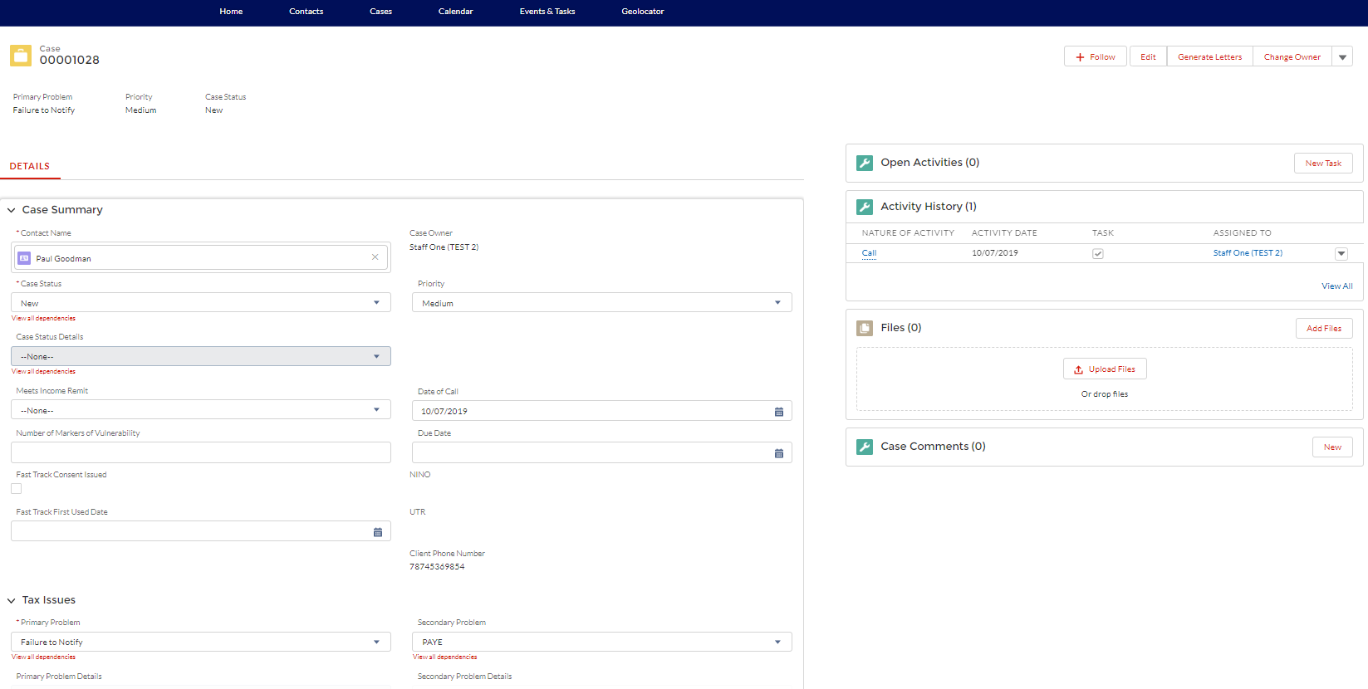

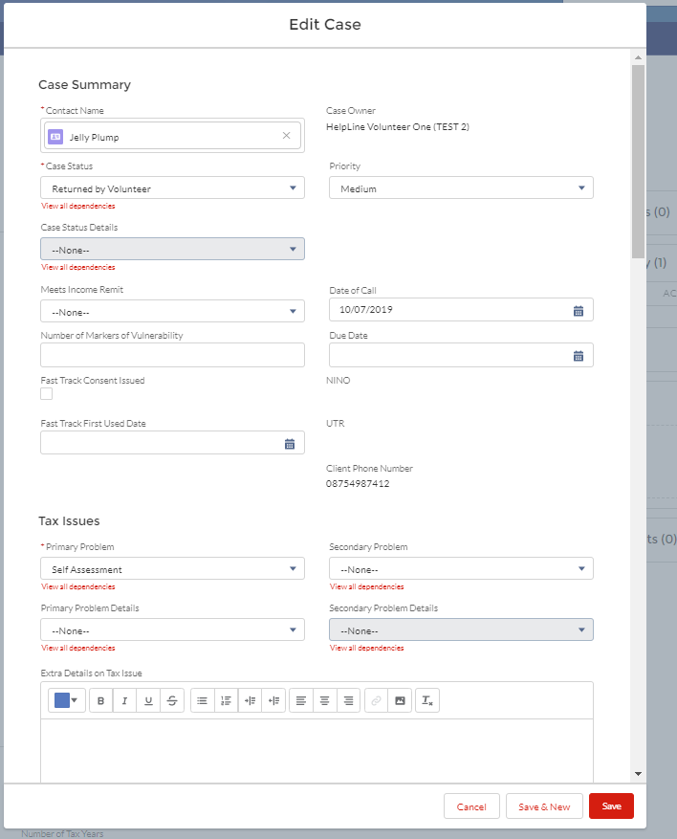
- 3.2b - Case owner – Update the Case owner as necessary – from the person who is closing a record (i.e. you) to:
- FOR HELPLINE VOLUNTEERS – from “yourself” to the Helpline Manager e.g. Sam Stent by going to the top right and clicking ‘Change Owner’
- FOR LONDON STAFF WHO ARE ON THE HELPLINE – no need to change the case owner. You will stay as a case owner.

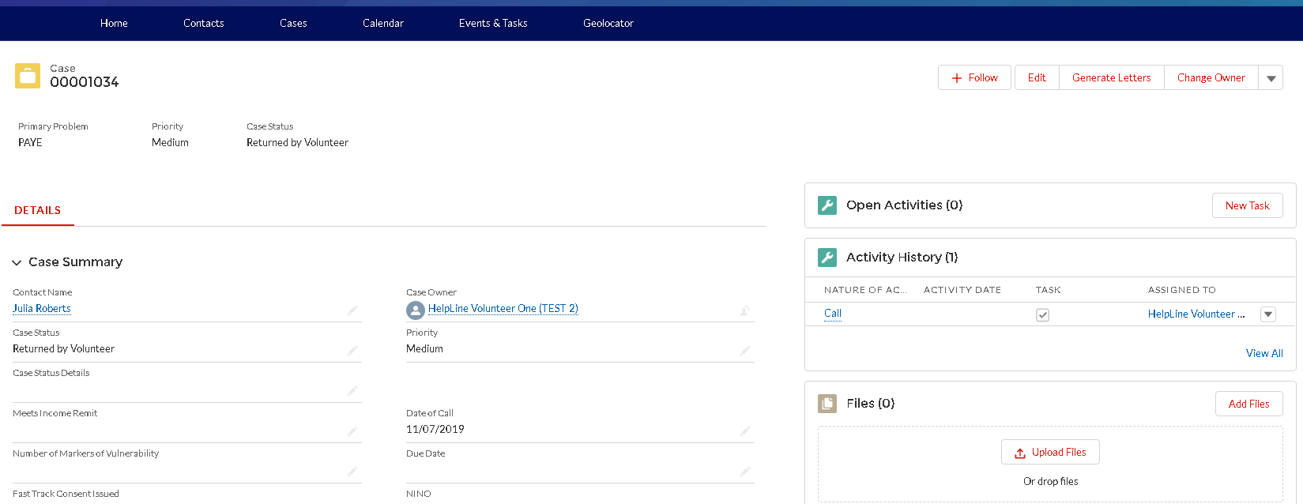

- To check that you succesfully change the case owner click on the Cases tab.

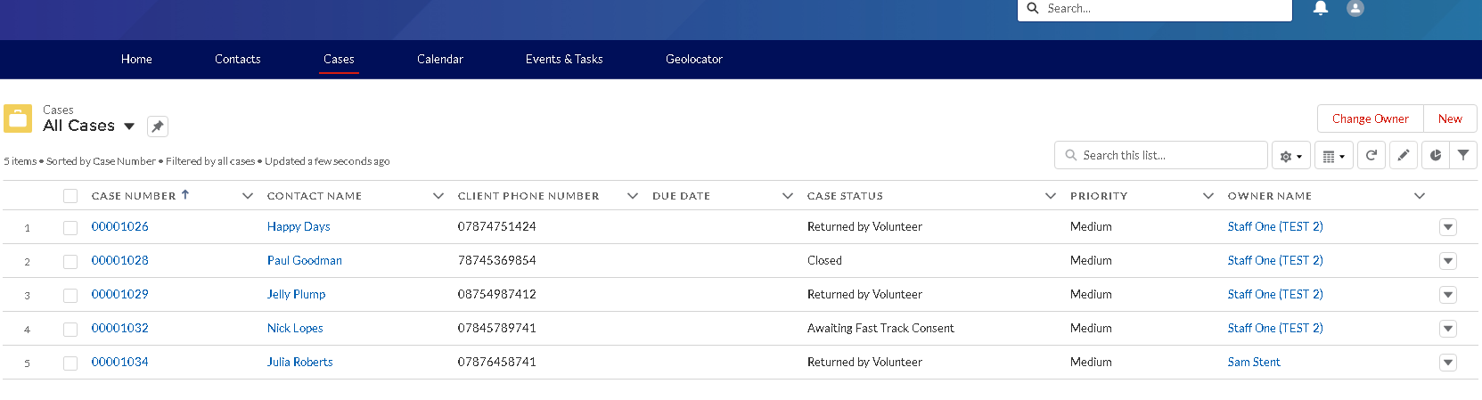

Sending information to a client (Email or Letter)

If during the call you identify that you need to send some information to the client, you can do so by sending the client e-mail or by sending a letter. After sending the information to the client please update the ‘comments’ of the ‘task’ ‘Initial call’ that document the call to state that. Ie- as follows

B.1 Sending an Email to a Contact ( this notes how you send out an email/letter in response to the initial helpline call’

This is two step process:

- Compose email
- Create task of ‘client interaction’ to advise email sent and copy email content to task.

1 Compose email:

- Navigate to the “contact page“ ie you compose an email when viewing the contact details, not the case details,
if you are in the ‘case’ details you need to click on the ‘contact name’ in the case summary and it will bring you to the ‘contact details’
- When in the ‘contact details’ , on the right side of the screen, there is an “Email” tool. This can be used to send emails to contacts from Salesforce.
- Click on Write an email…, or Compose.
- The Email tool then expands as follows.
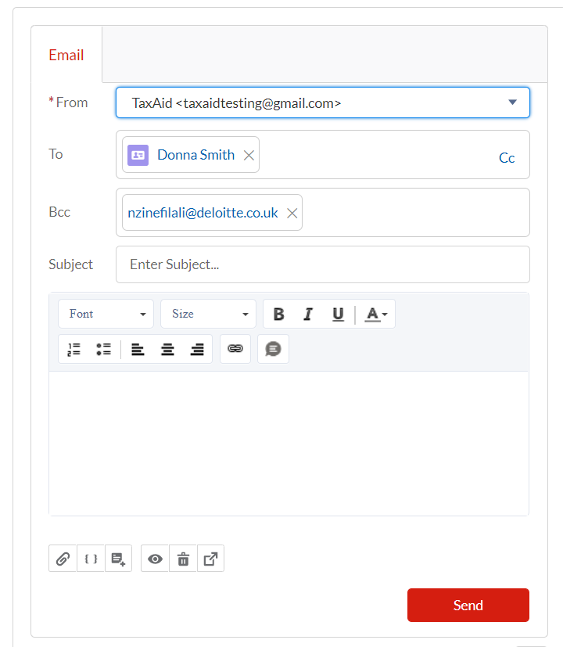

In the From field: select the ‘tax charity’ email address and not your personal email address.
- In the Subject field: include the Case Number this email is referring to. (this is very important – this is how any reply will be matched back to the record)
- At the end of your email, include your name.
- If a response is received it will be included as casework to allocate by Karen as it is at the minute. IE the purpose of this process is to ensure that the initial emails from helpline calls ALL come from the generic email address. Any response from the ‘generic email address’ will go first to the charity’s email inbox. ( to Karen – as current email enquiries do)
- Please ensure you follow the above steps as this is essential in relating emails to the correct cases.

- Create task of ‘client interaction’ to advise email sent and copy email content to task.

The email that you have just sent will be recorded in the ‘Contact’ record. Ie not the list of ‘tasks’ and ‘activities’ so sent emails will not be automatically shown in the Case record. Therefore to track sent emails, you must create a ‘task’

- Create a task:
- Assigned – to you as the helpline adviser sending the email
- ‘Nature of ‘Activity’ of this task is ‘Client interaction’
- Comments – ‘email sent to client’,
- Copy content of email into ‘task’
This routine applies to all emails sent to clients as a consequence to the initial helpline call in order to ensure all emails are sent to clients through the generic TaxAid helpline email address. ( Separate protocols are appropriate for emails sent in the course of casework dependent on the status of the caseworker)
- Case status –‘ complete’

B.2 Sending a Letter to a Contact

To write a letter to a contact, you need to be in the ‘case’ details, where there is a tool to ‘generate letters’. This can be used to generate letters to contacts from Salesforce.

- Helpline Volunteers – sending a letter to a contact is relevant when providing the client with the appointment letter or fast track form, ie it is a standard letter. Therefore what is needed is that you ‘create a task’ and Karen will issue the Standard letter. See ‘create a new task’ below.

- For Staff – sending your own letters, follow the instructions below to generate the standard letter and amend if necessary, you then ‘save’ the letter (with amendments as needed) to your PC and ‘upload’ it into Salesforce. Ie you must save the letter to your PC and then upload to Salesforce ( you will see the option to do this on the ‘Case summary details’ page ( click on client reference number to bring you to the ‘case details page’ Once saved to your PC you can print and send or email the letter- see the instructions on sending an email.

As for helpline volunteers - If you cannot print and send the letter, you can create a task for the Office Manager to send/email a standard letter, ie following the instructions below for helpline volunteers.

Create a new Task:

- Nature of activity will be – ‘Client interaction’ – when you are sending info to the client ( ie this is not the activity for sending the appointment letter or fast track form.)
- Activity date – date when you created the task;
- Assigned to:
FOR HELPLINE VOLUNTEERS: change assigned to the Office Manager e.g. Karen – click on the grey pen;
FOR LONDON STAFF: - IF YOU WANT TO EMAIL THE LETTER If you are sending the letter, and not asking Karen to send it, there is no need to change ‘Assigned to’, just keep it as assigned to you and follow the instructions below to ‘generate’ a letter’
- Task Status:
- FOR HELPLINE VOLUNTEERS: ‘in progress’
- FOR LONDON STAFF: If you are sending the letter by post and will print and send it, change the ‘task’ status to ‘complete’ because you will have sent the letter. If you are assigning the task for Karen to do, the task should show ‘In progress’ as Karen will show as ‘complete’ when she has completed the task.
- Comments
FOR HELPLINE VOLUNTEERS: ask the Office Manager to issue the letter you have prepared to provided information as a consequence of the initial helpline call. , eg ‘Karen please issue the appointment letter for appointment for contact, provide date and time of appointment, and add any more details if changes are needed to the letter – NB this should only be by exception.
FOR LONDON STAFF: Update the comments to state ‘letter sent to client.’ Or Office Manager to email appointment letter, provide date and time of appointment.’
- Click Save

FOR STAFF ONLY – to generate letters you will send/email yourself

Click on ‘Generate letters’

From the list of documents listed, click in the box in the first column on the left to choose the document you want to create.

At the bottom of the screen, click .’Next Step’

The document is created and you can view and amend the document. In the page presented after you have clicked ‘next step’ click on the ‘document number’ or ‘view’ to review/amend the letter.

Save the document to your PC and print ( ie this works through Word on your PC)

Then you need to ‘Upload’ the document to Salesforce. This is done from the ‘case summary’ page where there is the option to ‘upload’ or ‘drop files’

Update case summary REMEMBER THE ORDER IS IMPORTANT – YOU MUST UPDATE THE CASE STATUS BEOFRE THE CASE OWNER
Update two fields:

Case status – change the Case Status by clicking on a grey pen or by clicking on Edit

- FOR HELPLINE VOLUNTEERS – from “New” to “Returned by volunteer”
- FOR LONDON STAFF WORKING THE HELPLINE – from “New” to “Closed” if no further actions are required, or ‘Awaiting appointment or’ or awaiting fast track’ etc.

Case owner - Change the Case owner – from the person who is closing a record (i.e. you) to:
- FOR HELPLINE VOLUNTEERS – from “yourself” to the Helpline Manager e.g. Sam Stent by going to the top right and clicking ‘Change Owner’
- FOR LONDON STAFF WHO ARE ON THE HELPLINE – no need to change the case owner. You will stay as a case owner.
- And then click Save.

Sending out a fast track form

In the situation where a case has to be handled via a FastTrack form. The following steps should be completed:

Create a new Task:

- Nature of activity will be – FTTS;
- Activity date – date when you created the task;
- Assigned to:
FOR HELPLINE VOLUNTEERS: change assigned to the Office Manager e.g. Karen – click on the grey pen;
FOR LONDON STAFF: no need to change Assigned to, just keep it as assigned to you;
- Task Status:
- FOR HELPLINE VOLUNTEERS: keep work in progress
- FOR LONDON STAFF: Change to Work Completed (because it will be you who will be issuing the FT form – follow the instructions on sending a letter in order to do this)
- Comments:
FOR HELPLINE VOLUNTEERS: just ask the Office Manager to issue a FTTS ( fast track )form to this client eg ‘Karen please issue a Fast track from’
FOR LONDON STAFF: Update the comments to state ‘Fast Track form issued.’
- Click Save
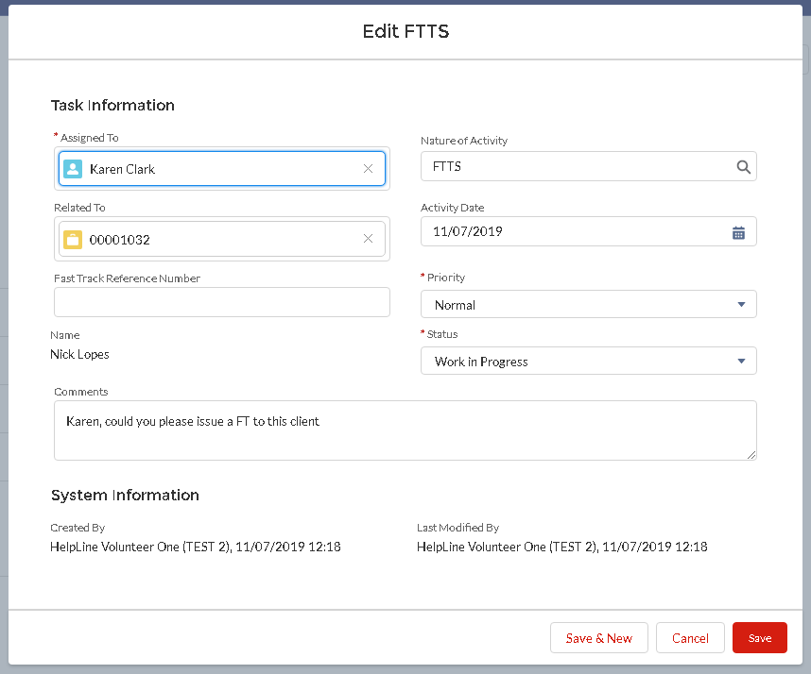

: Update case summary REMEMBER THE ORDER IS IMPORTANT – YOU MUST UPDATE THE CASE STATUS BEOFRE THE CASE OWNER
Update two fields:

Case status – change the Case Status by clicking on a grey pen or by clicking on Edit

- FOR HELPLINE VOLUNTEERS – from “New” to “Returned by Volunteer”
- FOR LONDON STAFF ON HELPLINE – from “New” to ““Awaiting Fast Track Consent”

Case owner - Change the Case owner – from the person who is closing a record (i.e. you) to:
- FOR HELPLINE VOLUNTEERS – from “yourself” to the Helpline Manager e.g. Sam Stent by going to the top right and clicking ‘Change Owner’
- FOR LONDON STAFF WHO ARE ON THE HELPLINE – no need to change the case owner. You will stay as a case owner.
- And then click Save.

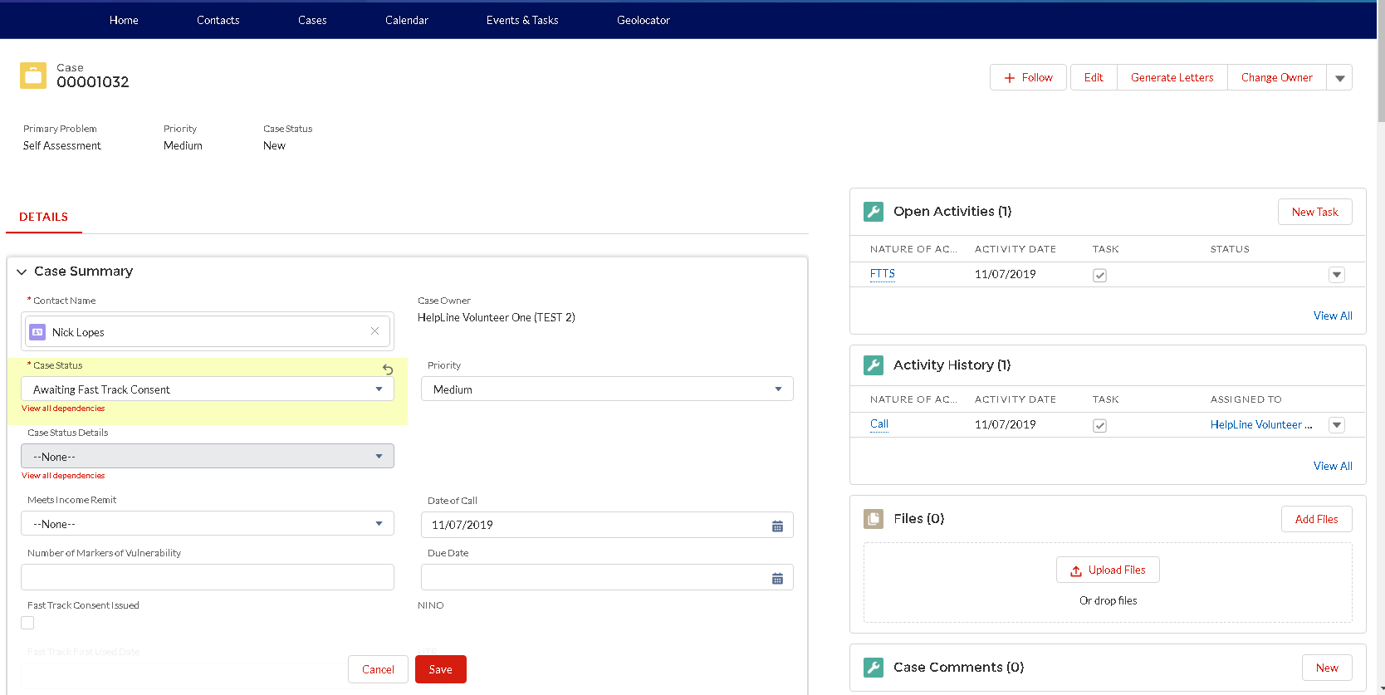

Below screen shots demonstrates original case owner (i.e. helpline volunteer) and the new case owner Sam – Helpline manager.
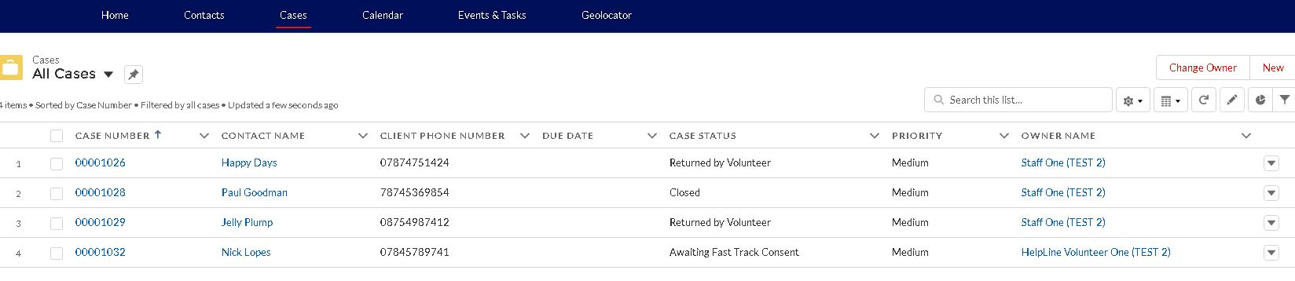

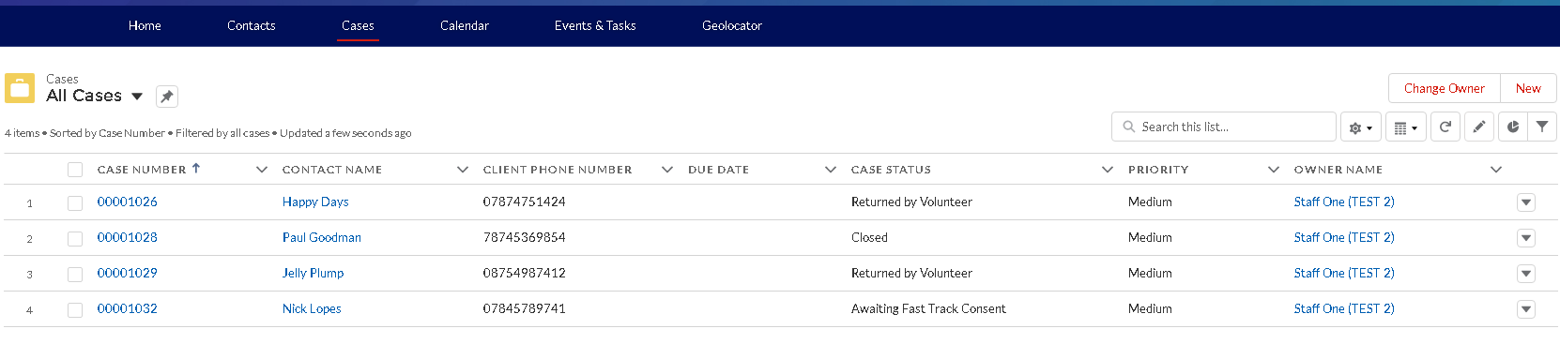

:FOR OFFICE MANAGER AND HELPLINE MANAGER ONLY
The Office Manager will receive the automatically generated email request to issue the fast track form and will check with the Helpline Manager before issuing the fast track form. If the issue of the fast track form is agreed the Office Manager will issue a FT form, and then change the case record status from “Returned by volunteer” to ” to “Awaiting FT consent “ .NB ‘ Task’ Status should now be changed to ‘completed’

Obtaining GDPR 3rd party consent
GDPR 3rd party consent form is usually sent together with the fast track form where GDPR consent has not been obtained on the initial call To record activity on the system please complete the following steps:

Create a new Task:

- Nature of activity will be – Letter;
- Activity date – date when you created the task;
- Assigned to:
FOR HELPLINE VOLUNTEERS: change assigned to the Office Manager e.g. Karen – click on the grey pen
FOR LONDON STAFF: no need to change Assigned to, just keep it as assigned to you;
- Task Status:
- FOR HELPLINE VOLUNTEERS: keep ‘Work in progress’
- FOR LONDON STAFF: Change to Work Completed (because it will be you who will be sending the Letter and FT form ie follow the instructions on ‘writing a letter and choose the appropriate standard letter’
- Comments:
FOR HELPLINE VOLUNTEERS: just note ‘Office Manager to send the GDPR letter and FT form to this client’
FOR LONDON STAFF: Update the comments to state ‘GDPR 3rd party consent and Fast Track forms were sent to the client.’
- Click Save

Update case summary REMEMBER THE ORDER IS IMPORTANT – YOU MUST UPDATE THE CASE STATUS BEOFRE THE CASE OWNER
Update two fields:

Case status
- FOR HELPLINE VOLUNTEERS: “Returned by volunteer”
- FOR LONDON STAFF: “Awaiting GDPR consent”

Case owner - Change the Case owner
- FOR HELPLINE VOLUNTEERS – from “yourself” to the Helpline Manager e.g. Sam Stent by going to the top right and clicking ‘Change Owner’
- FOR LONDON STAFF WHO ARE ON THE HELPLINE – no need to change the case owner. You will stay as a case owner.

And then click Save.

Scheduling Client appointment ( F2F or Telephone etc.) via a calendar & how to add Calendars

To note – the Calendar tab is used to schedule and view events. Events include volunteer availability, client appointments and other events such as bank holidays. For each charity location, there is a separate calendar that captures all the related events. The ‘calendars’ tab operates much as ‘google calendar’

- 1 How to add calendars(Bookmark calendars)
Helpline staff and volunteers will need to schedule or modify client appointments in specific locations ( eg KPMG Manchester). Each location has a calendar. It is useful to “bookmark” relevant charity locations calendars for ease of access, ie so that you can see the calendars that are relevant to you. The following steps demonstrate how to “bookmark” a location’s calendar. WHEN YOU HAVE ‘BOOK MARKED’ THE CALENDARS ONCE YOU WILL NOT NEED TO REPEAT THIS STEP, THEY WILL APPEAR IN YOUR LIST OF CALENDARS EACH TIME YOU LOG IN

Go to the Calendar tab.
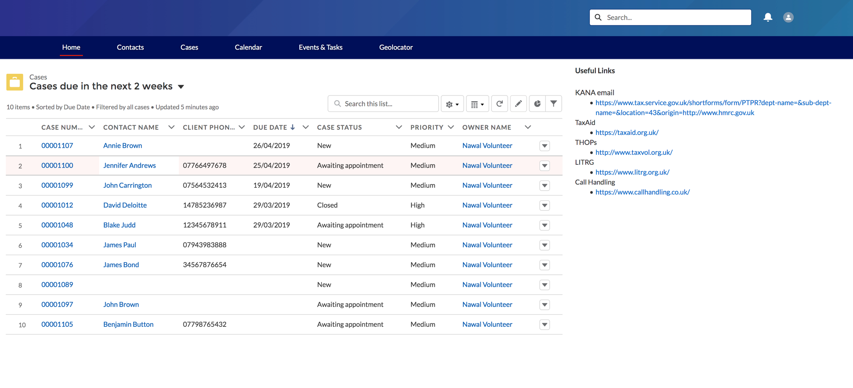

On the right side of the screen, next to Other Calendars, click on the settings button and then click Add Calendar.
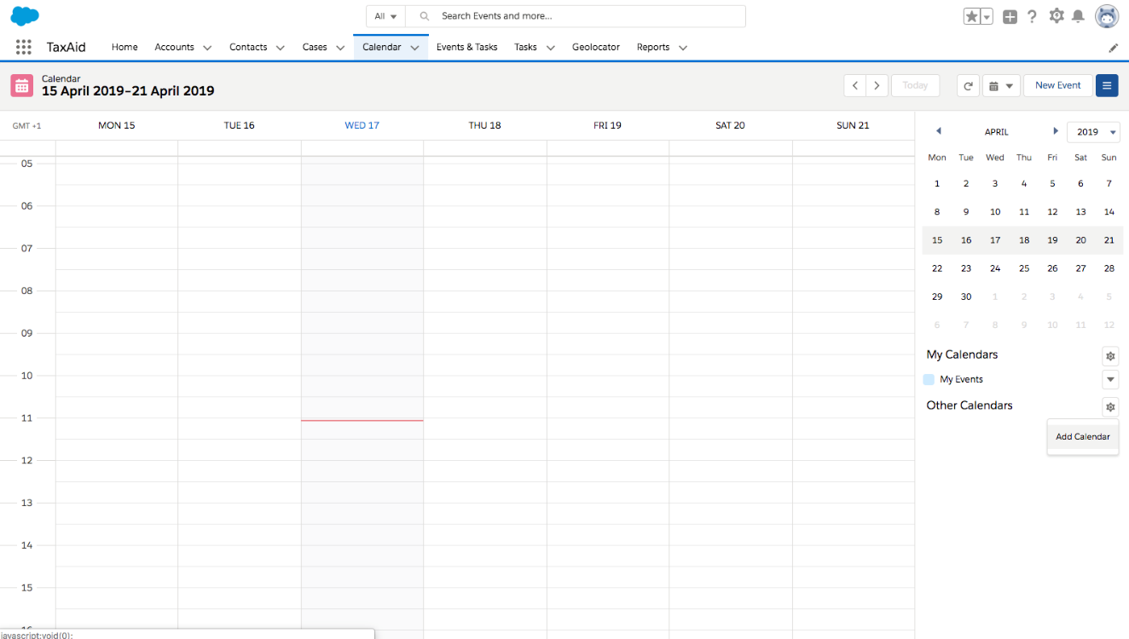

Type the name of the charity location in the Search Users… box.
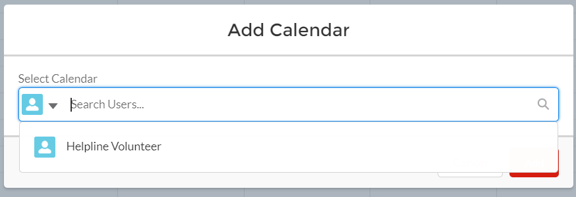

As you start typing in the search box, you will receive suggestions of locations containing the letters that you typed.

Once you have found the desired location, click on Add.

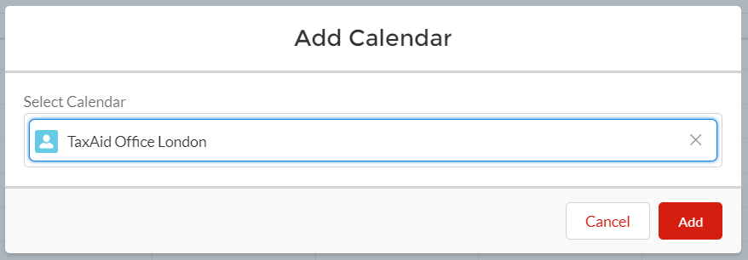

You can change the colour associated with a calendar by clicking on the arrow next to the calendar name and selecting a colour.

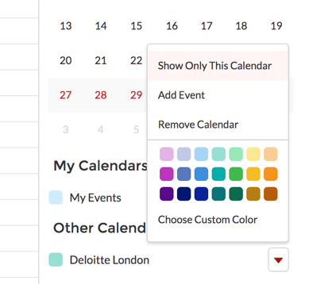

E. 2 Scheduling Client Appointments

You need to both set up the appointment in the calendar (which works much as google calendar) and;
Notify the client of the appointment .
The Case Summary has to reflect the action you have taken.

NB it is possible to ‘create a placeholder’ where you do not have time in a call to create the appointment, so you can ‘create a placeholder to keep the place while on the helpline and when you are able to write up the call later, you change the ‘placeholder ; to an appointment. The ‘placeholder’ process is explained in the next section.

This section explains how to schedule an appointment and let the client know by the appointment letter.

Scheduling the appointment.

Client appointments should be scheduled by changing an ‘Availability Event’ into a ‘Client Appointment’ on the calendar. The following steps demonstrate how to do this.

From the Calendar page, navigate to the relevant week/day. Click on the availability you want to change into a ‘Client Appointment.’
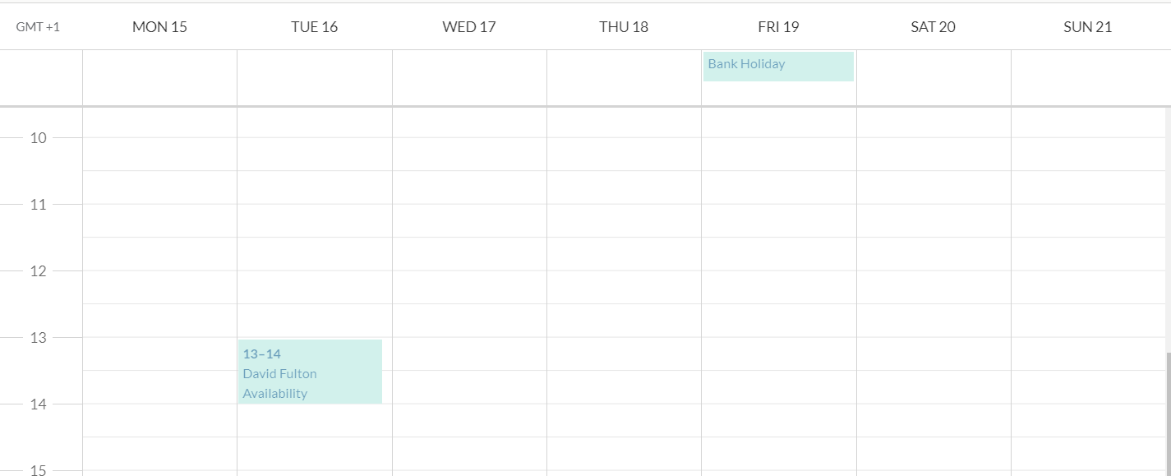

You will be directed to the record page for this Event. Click on ‘Change Record Type’. This step is very important as this allows you to change an availability into a client appointment.
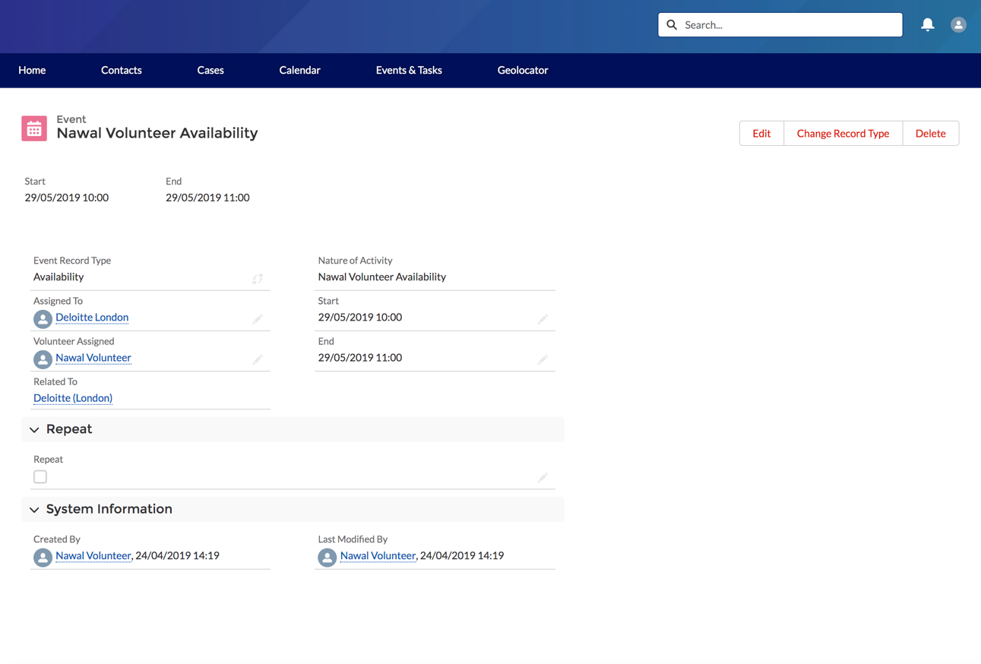

Select Client Appointment and click Next.
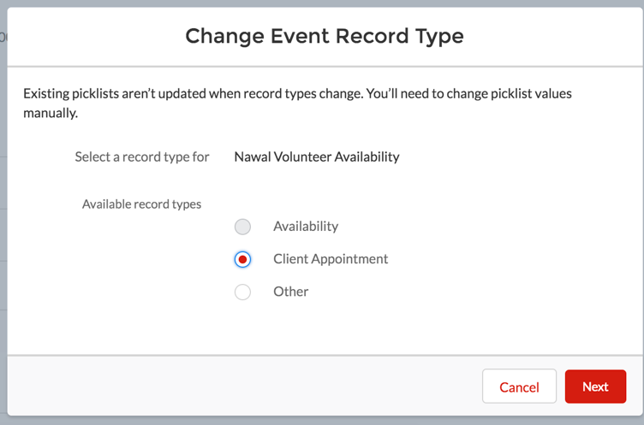

On the following screen, it is very important to relate the appointment to the relevant case and update the nature of the ‘activity’.
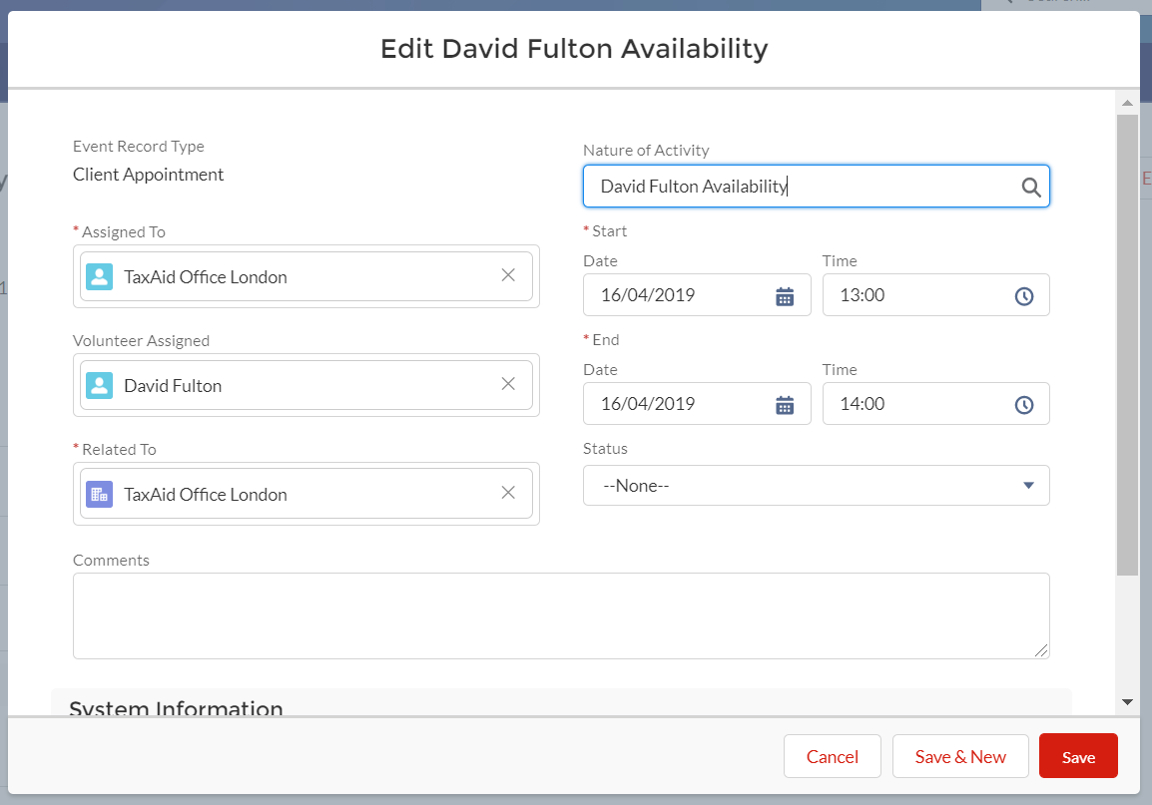
The page illustrated above should be completed as follows:

Assigned To - refers to the location where this appointment is available.
Volunteer Assigned - refers to the volunteer who is available during that time slot. This might be empty. It is very important not to change Assigned To and Volunteer Assigned (whether it is filled or blank). ( ie the volunteer assigned to the appointment, whether this is a face to face appointment or telephone appointment is dependent on the volunteer availabilty.

Related To - click on the cross (X), then select Cases from the dropdown, then add the case that this client appointment relates to.
Nature of Activity - select the relevant option and add the case number e.g. London F2F – Client Name 00001016.( you can type in this box to add the case number)

Comments – To add briefly what the issue is and direct the volunteer to follow the relevant ‘how to guides’ Ie detailed instructions are not necessary
For Status, select Scheduled.
Click on Save.

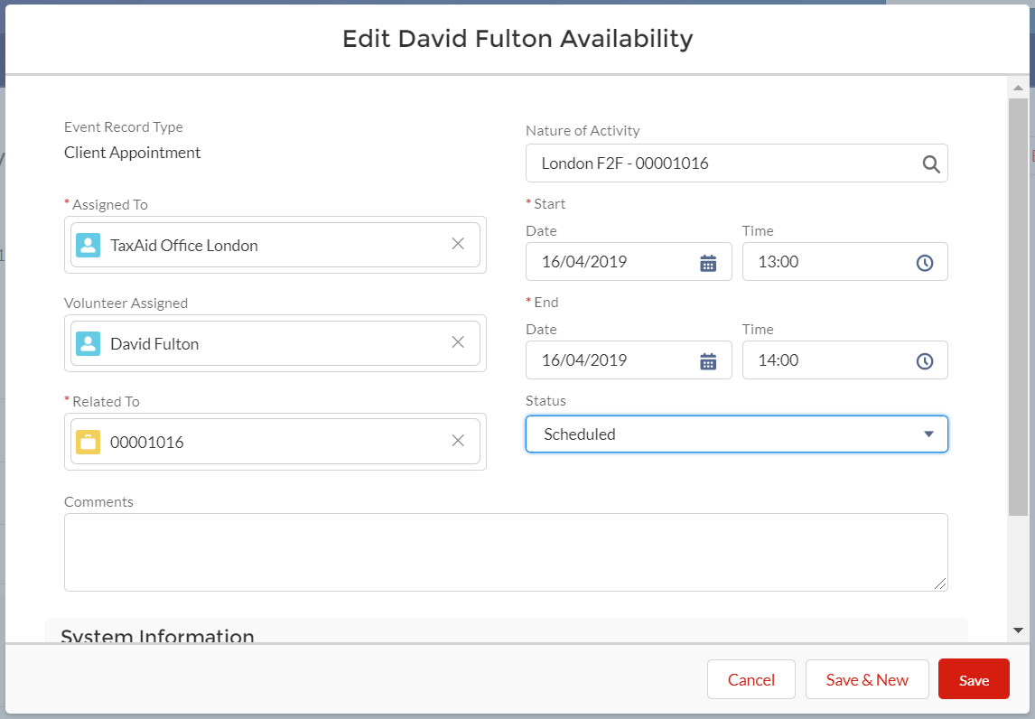

Note: The above steps are very important to ensure that the Volunteer Assigned gains access to the Case and the Client (Contact) details.

If the Volunteer Assigned was blank, a coordinator will assign the Case and Client Appointment to a Volunteer.

To inform the client about the details of the appointment you have made:

Create a New Task – to create an appointment letter to let the client know the date and time of the appointment – Section 4 B - Sending information to a client (Email or Letter), above.

Finally as with completing all events/tasks – you need to update the case summary

REMEMBER THE ORDER IS IMPORTANT – YOU MUST UPDATE THE CASE STATUS BEOFRE THE CASE OWNER

Update two fields:
:

Case status
- FOR HELPLINE VOLUNTEERS: “Returned by Volunteer”
- FOR LONDON STAFF: “Awaiting Appointment”

Case owner - Change the Case owner
- FOR HELPLINE VOLUNTEERS – from “yourself” to the Helpline Manager e.g. Sam Stent by going to the top right and clicking ‘Change Owner’
- FOR LONDON STAFF WHO ARE ON THE HELPLINE – The case owner should be the volunteer taking the appointment .

And then click Save.

Making a reservation/placeholder in a calendar

When it is not possible to create a ‘contact’ and a ‘case’quickly enough to be able to schedule a client appointment while speaking to the client on the helpline, it is possible to hold placeholders for client appointments in the calendar to prevent double booking.

From the ‘Calendar’ tab, navigate to the relevant week/day. Click on the availability you want to hold for a Client Appointment.
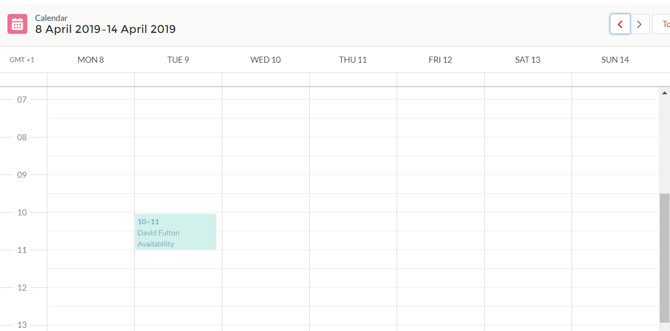

You will be directed to the ‘record page’ for this Event. Click on ‘Change Record Type’. This step is very important as this allows you to change an ‘availability’ into a ‘client appointment’ ie without having set up a case, which you might well not have done while on the live call.
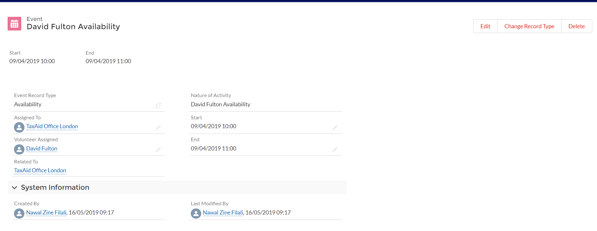

Select ‘Client Appointment’ and click ‘Next’
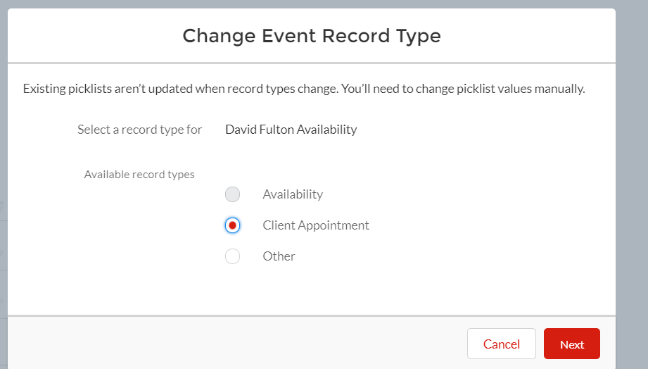

On the following screen, update the nature of the activity to reflect that this is a ‘placeholder’.
Assigned To - refers to the location where this appointment is available. Volunteer Assigned - refers to the volunteer who is available during that time slot, ie the slot on the calendar will show the volunteer who is availableThis might be emptyIt is very important not to change Assigned To and Volunteer Assigned (whether it is filled or blank).
Do not modify Related To.
For Nature of Activity, select Placeholder and append the client name.
For Status, select Scheduled.
Click on Save.
Once you have entered the Client (Contact) and Case, you can edit this placeholder and update the details so that the Client Appointment is related to the Case.
Under Related To, click on the cross (X), then select Cases from the dropdown, then add the case that this client appointment relates to.
For Nature of Activity, select the relevant option and append the case number, e.g. London F2F – 00001016.
For Status, select Scheduled.
Click on Save.
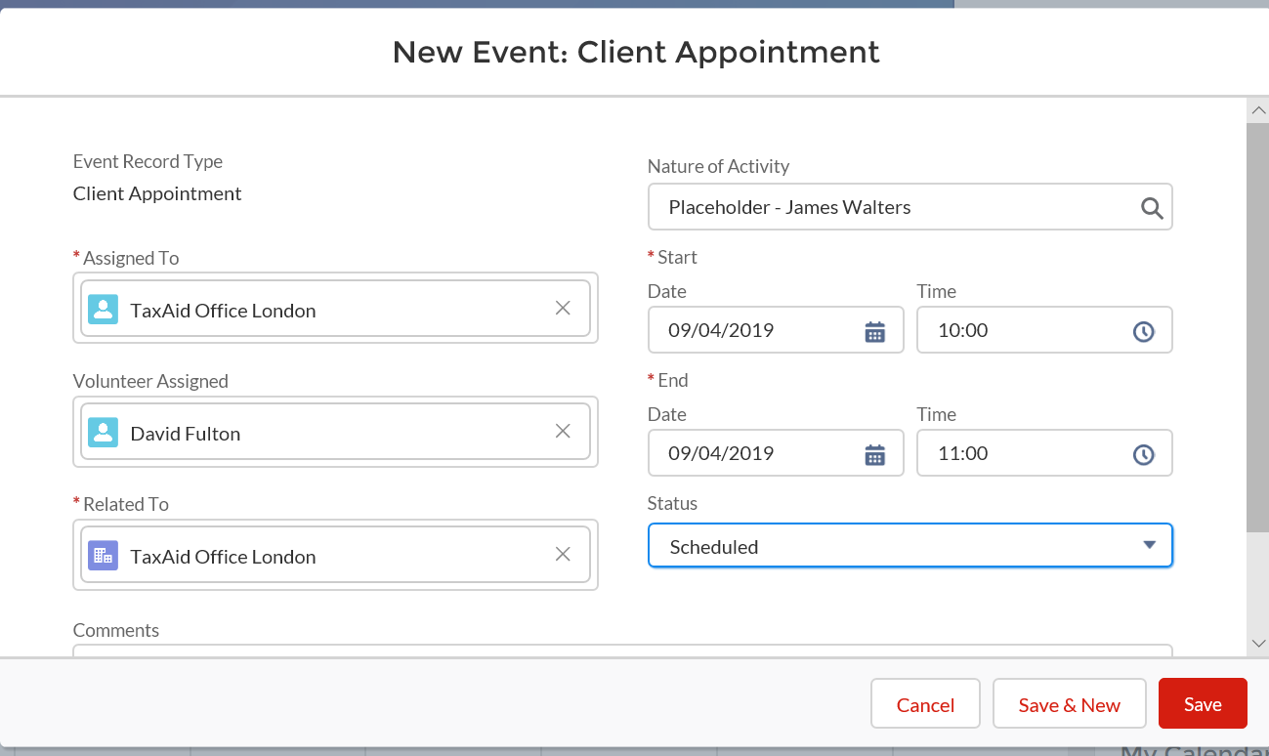

Asking Office manager to takeAudio consent

In the situation where a case has to be handled by a telephone appointment an audio consent had to be taken. The following steps should be completed (in addition to setting up the telephone appointment as defined in section ‘F’

Create a new Task:

- Nature of activity – Call
- Activity date – date when you created the tasks;
- Assigned to:
FOR HELPLINE VOLUNTEERS: change assigned to the Office Manager e.g. Karen – click on the grey pen;
FOR LONDON STAFF: change assigned to the Office Manager e.g. Karen – click on the grey pen;
Status:
- FOR HELPLINE VOLUNTEERS: keep work in progress
- FOR LONDON STAFF: keep work in progress
- Comments:
FOR HELPLINE VOLUNTEERS: ask the Office Manager to do an audio consent form to this client
FOR LONDON STAFF: ask the Office Manager to do an audio consent form to this client
Click Save
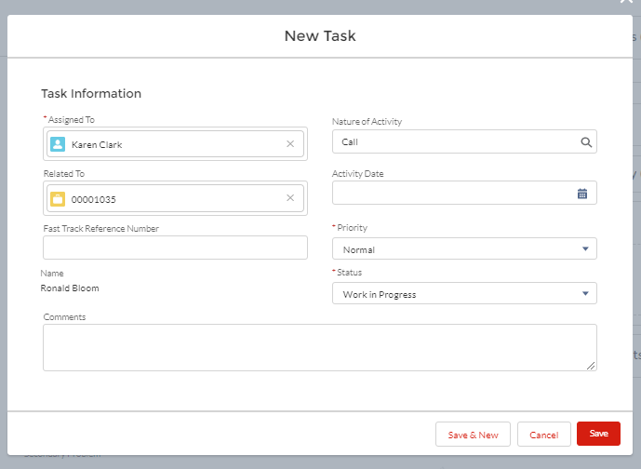

Update case summary REMEMBER THE ORDER IS IMPORTANT – YOU MUST UPDATE THE CASE STATUS BEOFRE THE CASE OWNER
Update two fields:
:

Case status
- FOR HELPLINE VOLUNTEERS: “Returned by Volunteer”
- FOR LONDON STAFF: “Awaiting Fast track consent”

Case owner - Change the Case owner
- FOR HELPLINE VOLUNTEERS – from “yourself” to the Helpline Manager e.g. Sam Stent by going to the top right and clicking ‘Change Owner’
- FOR LONDON STAFF WHO ARE ON THE HELPLINE – The case owner should be the volunteer taking the appointment for which the audio consent is needed .

And then click Save.

FOR OFFICE MANAGER AND HELPLINE MANAGER ONLY
The Office Manager will receive the automatically generated email request to obtain audio consent and will check with the Helpline Manager before issuing the fast track form. If audio consent is agreed the Office Manager will obtain audio consent, and then change the case record status from “Returned by Volunteer’ to “To awaiting appointment”. NB ‘ Task’ Status should now be changed to ‘completed’

Making a note of a call from the existing client who already have a TaxAid adviser allocated

In the instances where caller is an existing client, helpline volunteers will have to identify the current adviser, make a note of the call, by creating a ‘task’ as described above’
. Change “Assigned To” to the TaxAid adviser of this client and leave him/her a note in the comment box. The adviser will be alerted automatically by an e-mail, because you have ‘assigned’ the call to the adviser. Ie when you ‘assign’ a task or activity to someone, the person to whom you assign a ‘task’ or ‘ activity’ will be sent an email automatically – there is no need to separately email the advisor.
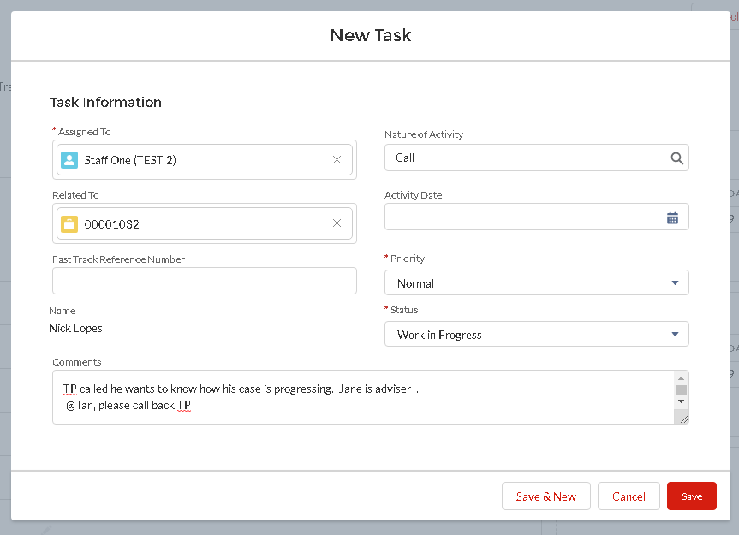

Editing the Case summary as you get more information from the client

Either from the initial telephone call or other points of contact you will get case relevant information which should be reflected on the case summary. Relevant information is helpful for doing follow up work on clients.

In order to update the case summary, from the ‘record page’ click on Edit; to edit specific fields – click on grey pen next to the field.

